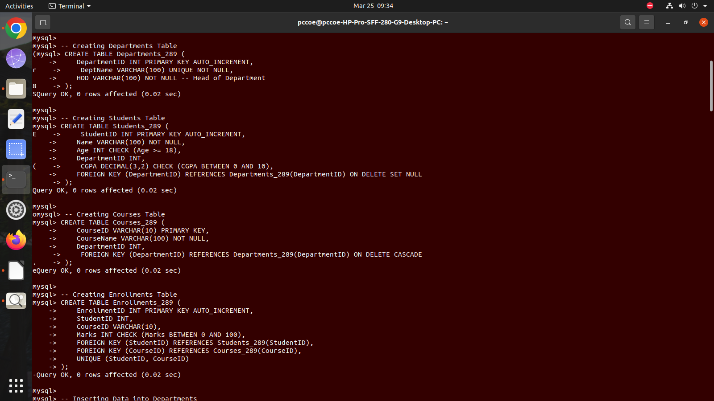
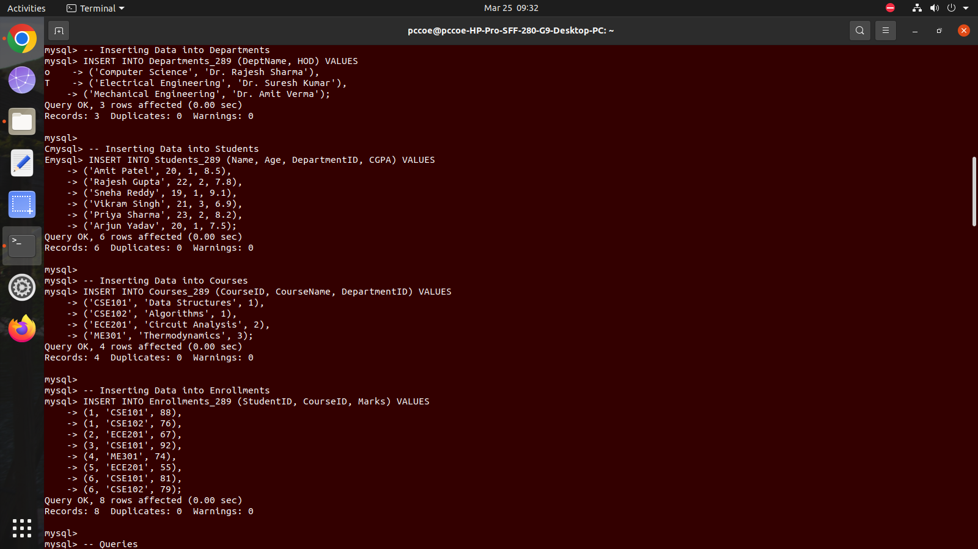
Assignment 7(DBMS)
TABLES:
VALUES:
QUERIES:
1. Find students who have a CGPA higher than the university average CGPA
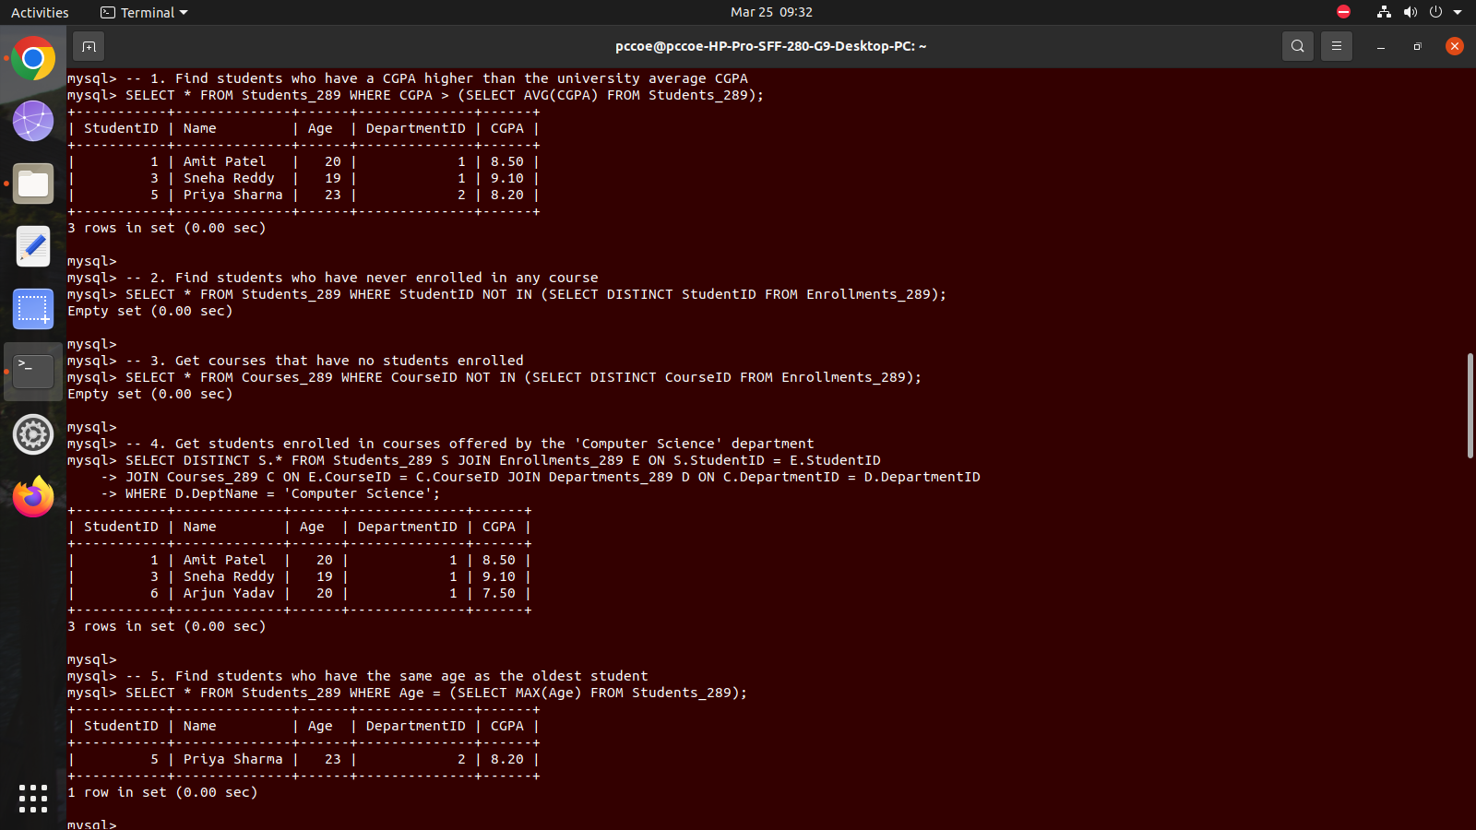
2. Find students who have never enrolled in any course


3. Get courses that have no students enrolled


4. Get students enrolled in courses offered by the 'Computer Sci' department

5. Find students who have the same age as the oldest student

6. Retrieve courses where at least one student scored more than 85 marks

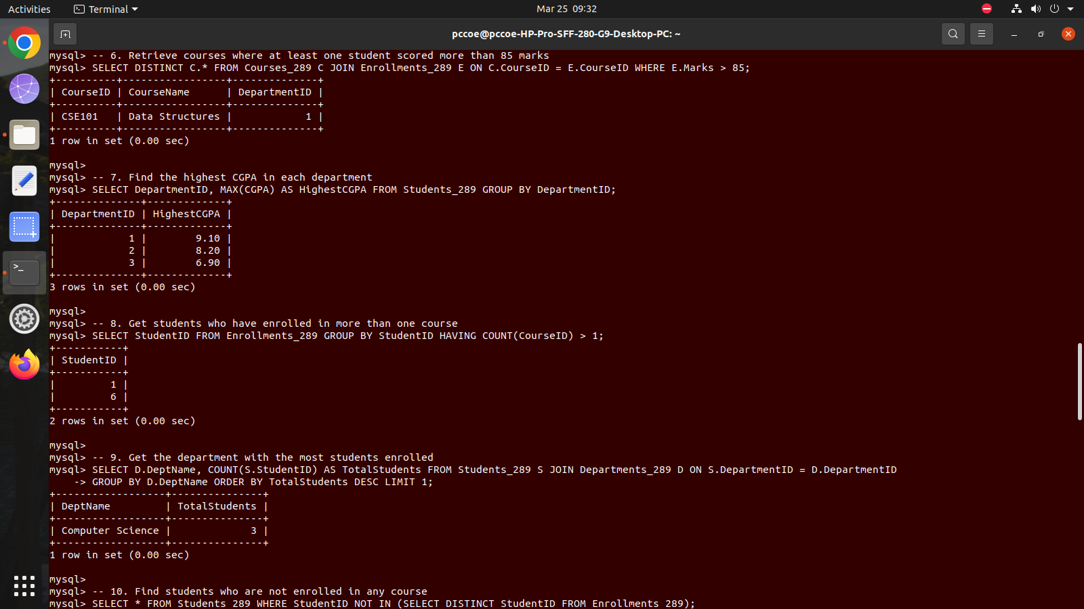
7. Find the highest CGPA in each department


8. Get students who have enrolled in more than one course

9. Get the department with the most students enrolled

10. Find students who are not enrolled in any course
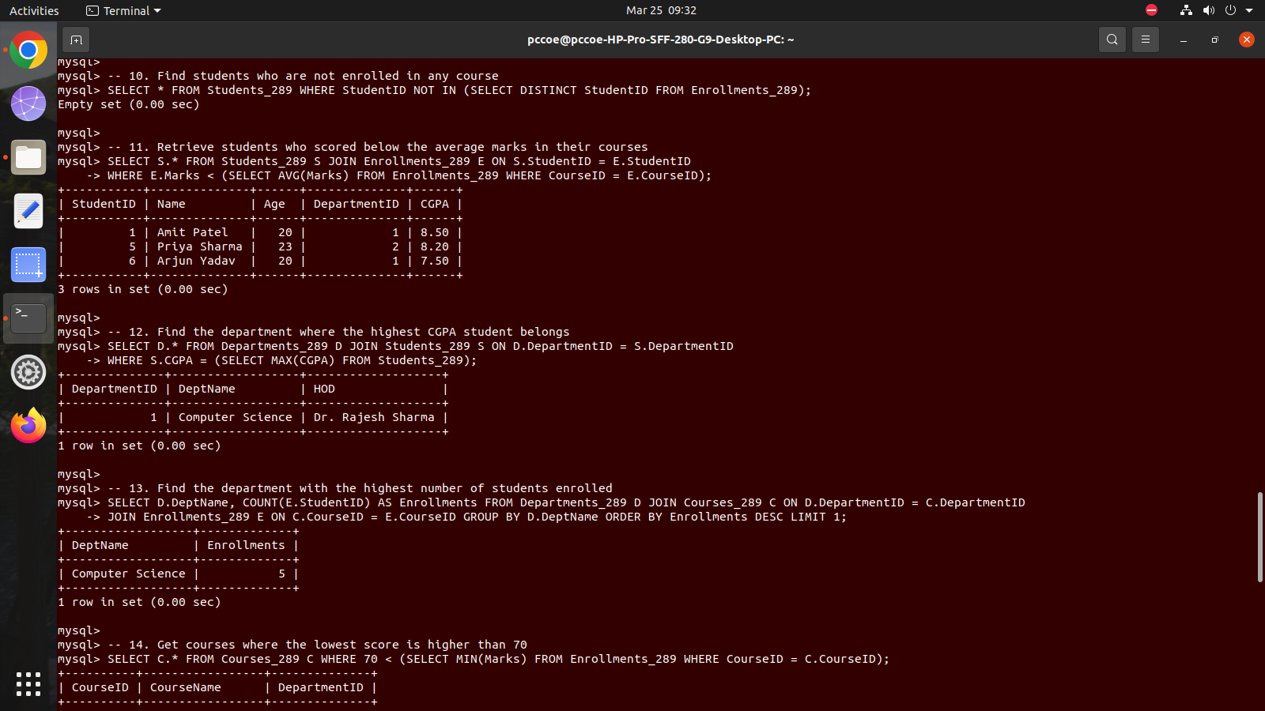
11. Retrieve students who scored below the average marks in their courses

12. Find the department where the highest CGPA student belongs


13. Find the department with the highest number of students enrolled

14. Get courses where the lowest score is higher than 70
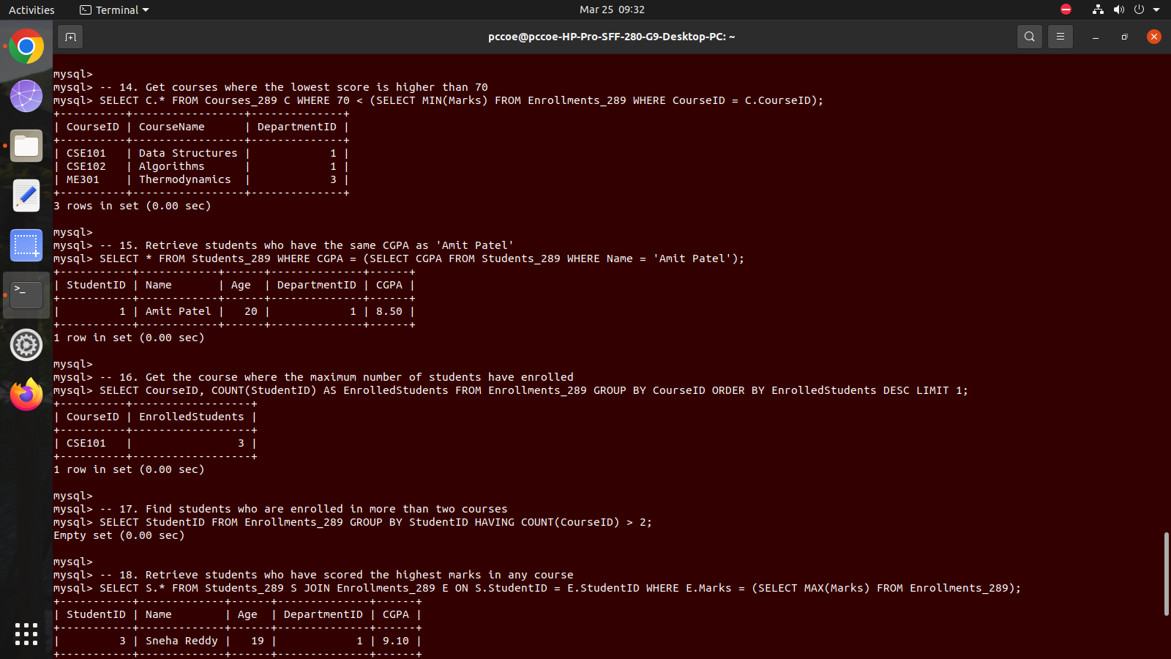
15. Retrieve students who have the same CGPA as 'Amit Patel'


16. Get the course where the maximum number of students have enrolled

17. Find students who are enrolled in more than two courses

18. Retrieve students who have scored the highest marks in any course(Hint: Use Join along with nested quesries).
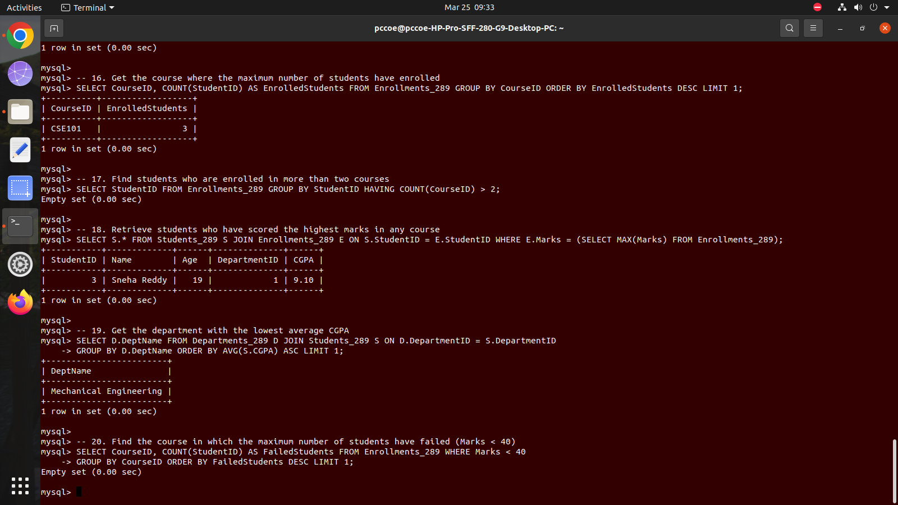


19. Get the department with the lowest average CGPA


20. Find the course in which the maximum number of students have failed (Marks < 40)

